**1.** Evaluate the following integral using Romberg Integration:

$\int_{1}^{2}{{\left(2x+ \frac{3}{x}\right)}^{2} dx}$

Given the true value is 25.83333333333333, iterate until true percentage error < 1% or upto order of $h^{16}$.

**2.** Numerically integrate

$$\frac{dy}{dx}= x^{3}-5x^{2}-x+6$$

from x = 0 to x = 4 with a step size of 0.5. The initial condition at x = 0 is y = 1.

(a) using Euler’s method

(b) Heun Method with a Single Corrector (second order RK method with $a_{2}$ = 1*/*2).

(c) The Midpoint Method (second order RK method with $a_{2}$ = 1)

(d) Ralston’s Method (second order RK method with $a_{2}$ = 2*/*3)

Now, compare the solutions above with the analytical true solution and plot the graph like the following one:

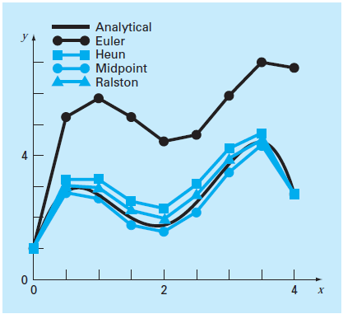

(Figure 25.14 from Chapra’s book)